DETERMINATION AND ANALYSIS OF KNEE OSTEOARTHRITIS USING CENTERNET AND PIXEL-WISE VOTING SCHEME

SOFTWARE REQUIREMENTS SPECIFICATIONS

BATCH D10

UNDER THE ESTEEMED GUIDANCE OF
Dr. G R Shakti Dharan
Professor, CSE, GRIET

TEAM MEMBERS

M PRITHVI - 21241A05P3
B DEVARJUN - 21241A05L1
Md. Z HAFEEZ - 21241A05P2
N HANISH - 21241A05P5

1 INTRODUCTION
1.1. Purpose
The purpose of this document is to specify the requirements for a deep-learning software that facilitates the detection of severity of knee osteoarthritis (KOA) from X-ray images. The application will use React for frontend and Flask for the backend. X-ray images will be processed using Pixel-wise voting scheme for image segmentation along with CenterNet to determine the gaps in knee joints. Based on the output, the application will generate a severity score which indicates the severity of KOA and recommend a suitable treatment plan. This document lists the functional and non-functional requirements for successful execution of the application and provides a view of the UML diagrams for a better understanding.

1.2. Scope
This deep learning software is designed to allow medical professionals to upload X-ray images for automated KOA analysis. It will:
- Take an X-ray image as input.
- Uses Pixel-wise voting scheme for image segmentation.
- Apply CenterNet algorithm for analysis of knee joint space.
- Generate a severity score for KOA based on the analysis.
- Suggest a suitable treatment plan.

This application makes use of current Deep Learning technologies, Object Detection algorithms, Computer Vision concepts , Flask framework and React JS for an important task i.e to detect and diagnose Knee OsteoArthritis (KOA) severity and suggest suitable treatment to help guide patient care.

1.3. Definitions, Acronyms and Abbreviations
- KOA : Knee OsteoArthritis.
- CenterNet: A keypoint-based object detection algorithm.
- React: JavaScript library Frontend.
- Flask: Python framework.
- DL : Deep Learning

1.4 REFERENCES

2 SYSTEM ARCHITECTURE

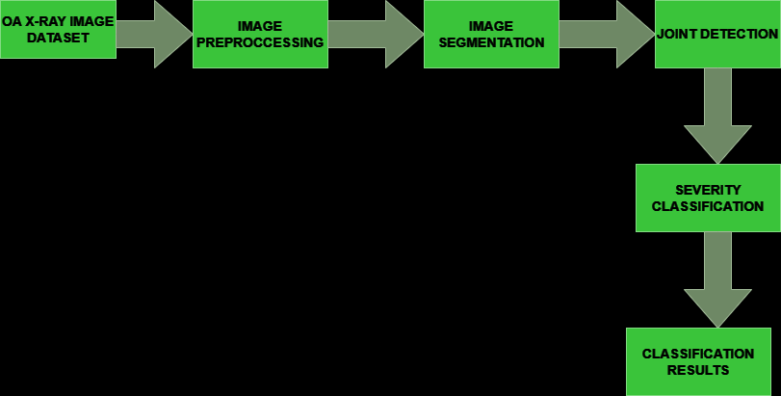

The above diagram represents the architecture of the proposed solution to determine and analyze the severity of Knee OA. The dataset is an annotated X-Ray image dataset which has bounding boxes enclosing the joints in the image. The new image, which is uploaded by the user, is preprocessed to a certain size and sent to CenterNet for detecting the joint area. CenterNet is an object detection algorithm which uses annotations to detect the specific area. It uses the annotations data to calculate the joint space and returns it to a trained DL model. Based on the joint space, the model returns a severity class, which can be used in future purposes.

3 FUNCTIONAL REQUIREMENTS

FR 3.1 Image Upload
- The system must support image of type files .png, .jpg, .jpeg
- The system should be able to determine whether the uploaded images are of correct format or not.
FR 3.2 Joint Detection
- The system must use CenterNet to locate joints in the area
- The detected region should be marked visually after applying the annotations file
- The detection results should be saved for future reference.

FR 3.3 Joint Space Measurement
- Using the CenterNet model, the system must be able to calculate the joint space
- The result must be scored for classification purposes..
FR 3.4 Severity Classification
- The system must support a trained deep learning model which takes the input of joint space and predicts the severity of the disease.
- This prediction must be displayed to the user.

FR 3.5 Treatment Recommendations
- The system must provide treatment recommendations based on a predefined set of rules correlating with the KOA severity score.
- The recommendations should include conservative treatments (e.g.,physiotherapy,weight management) for mild cases and more treatments..

4 NON-FUNCTIONAL REQUIREMENTS

The following is a list of Non-Functional requirements which must be followed for the running of the project.

NFR 4.1 Performance

- The application must be able to complete the process of uploading , preprocessing and delivering the output all within a minute of time.

NFR 4.2 Reliability

- The application must give an uptime of 100% i.e the application must be ready to use by the user at any time.

NFR 4.3 Security

- The image data uploaded must be encrypted during uploading, preprocessing and storage.
- The data must follow Healthcare guidelines and regulations.

NFR 4.4 Scalability

- The web-application must be scalable enough to support multiple users using it at the same time.

5 UML DIAGRAMS

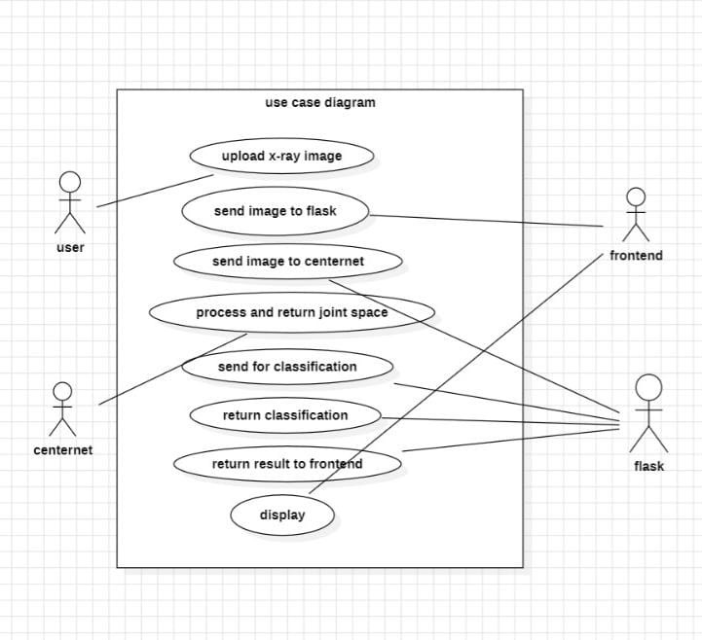
Fig 5.1 USE CASE DIAGRAM

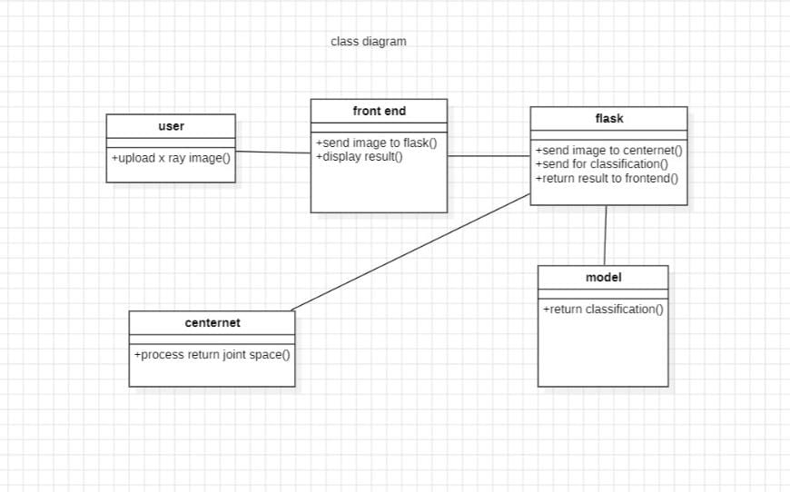

Fig 5.2 CLASS DIAGRAM

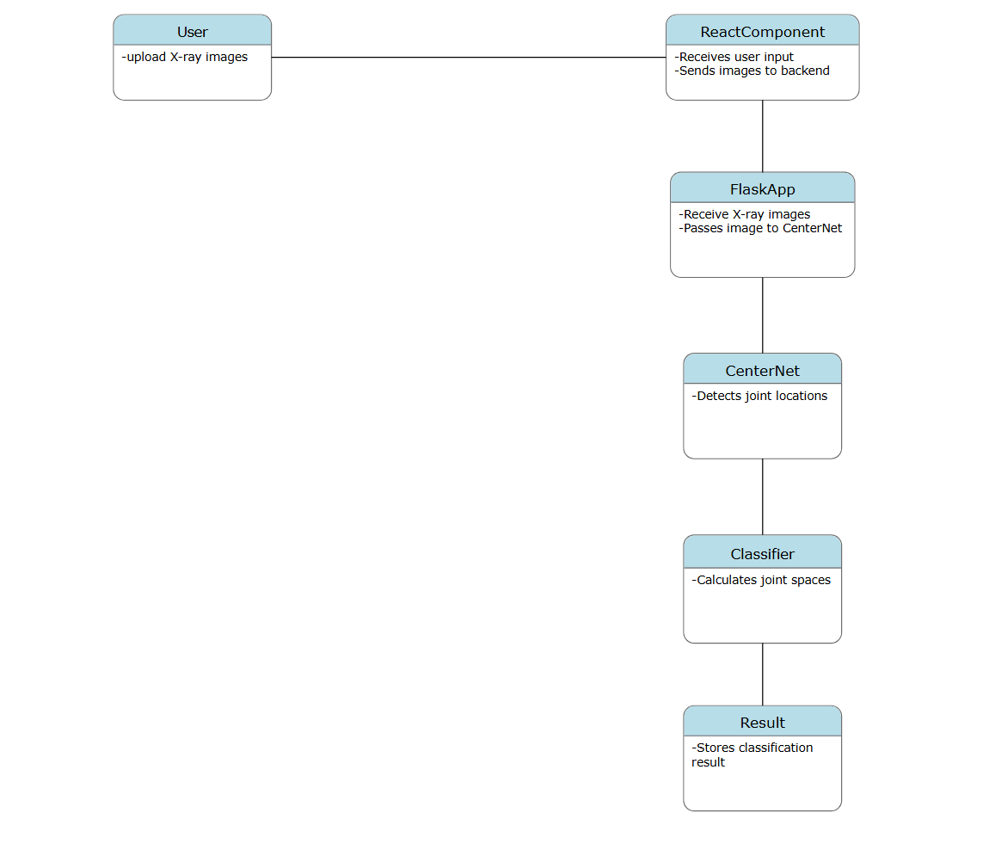

Fig 5.3 OBJECT DIAGRAM

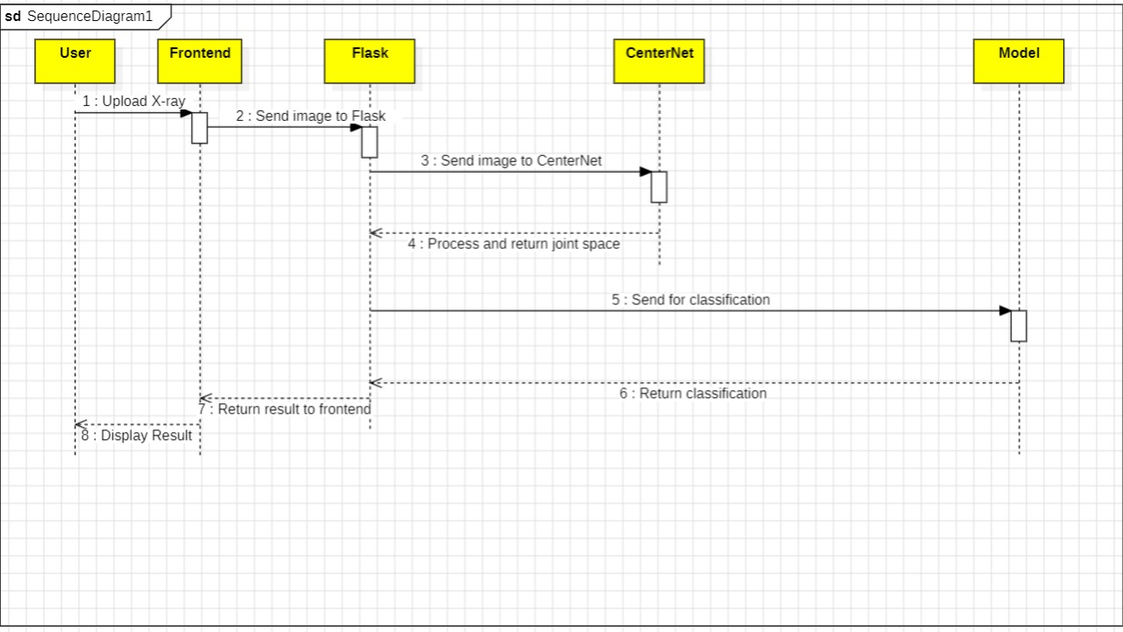
Fig 5.4 SEQUENCE DIAGRAM

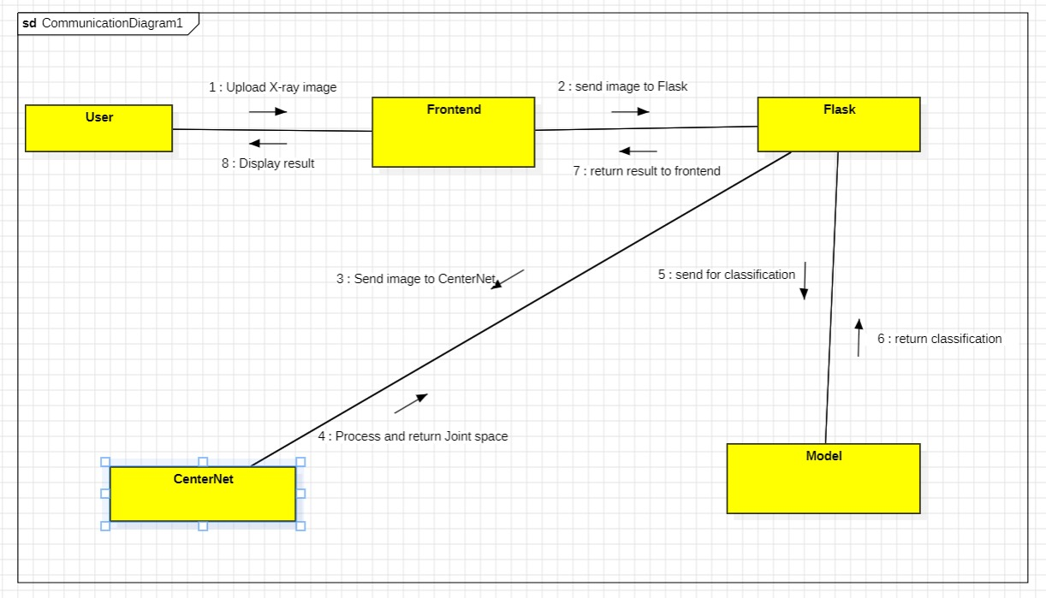

Fig 5.5 COLLABORATION DIAGRAM

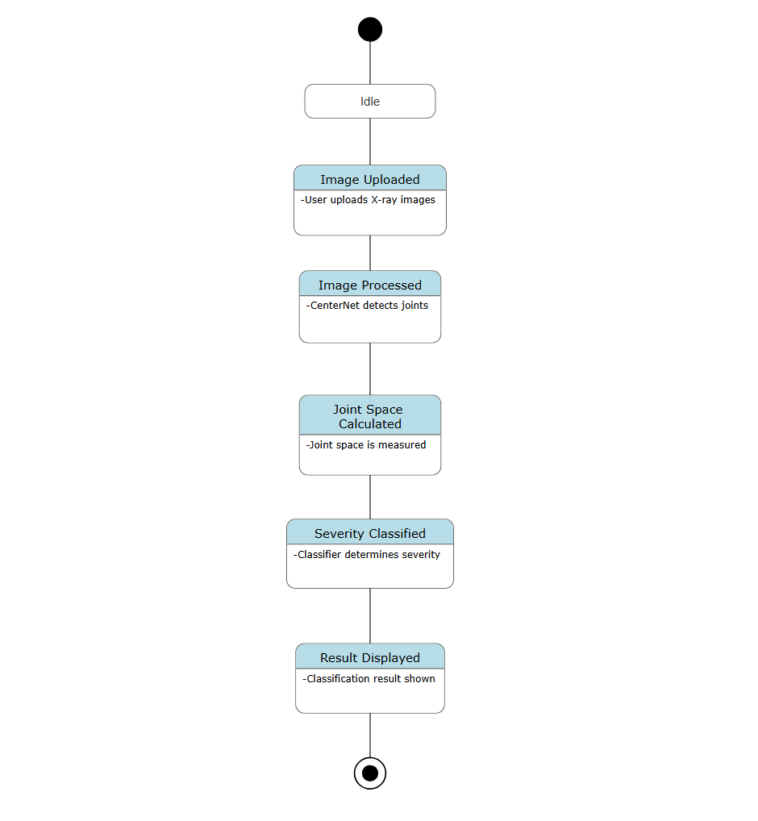

Fig 5.6 STATE CHART DIAGRAM
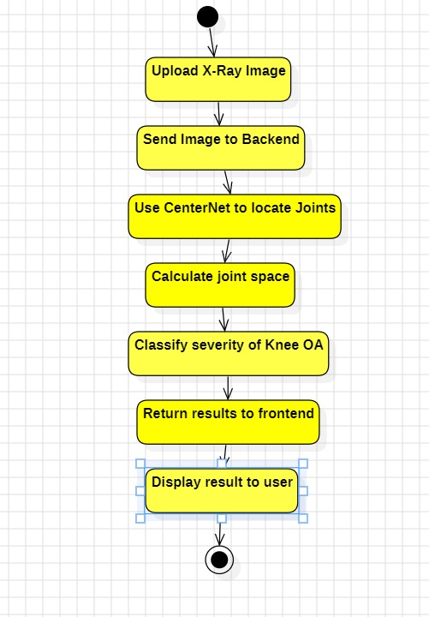
Fig 5.7 ACTIVITY DIAGRAM

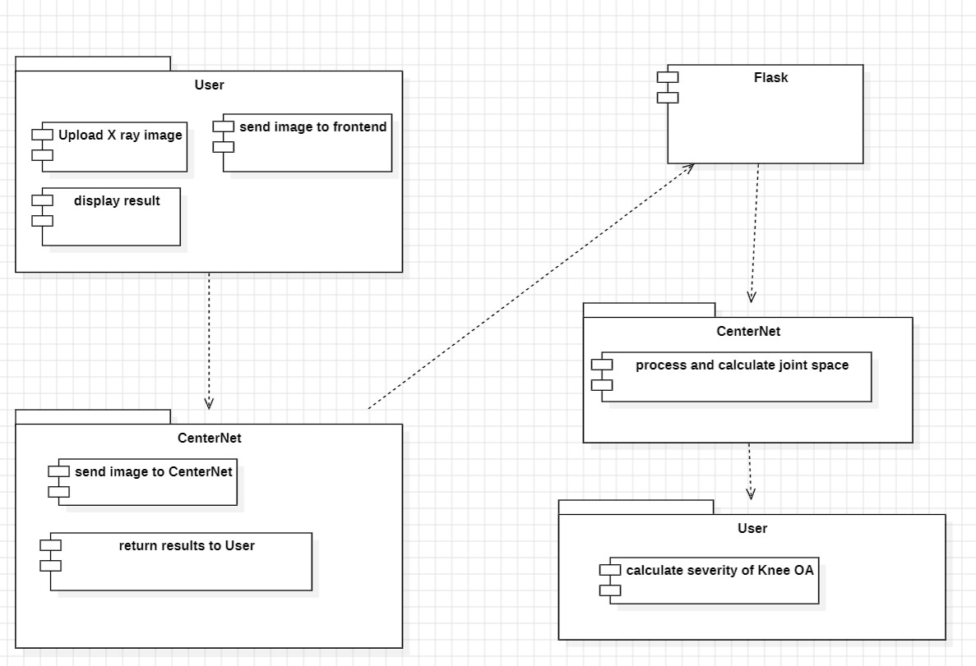
Fig 5.8 COMPONENT DIAGRAM

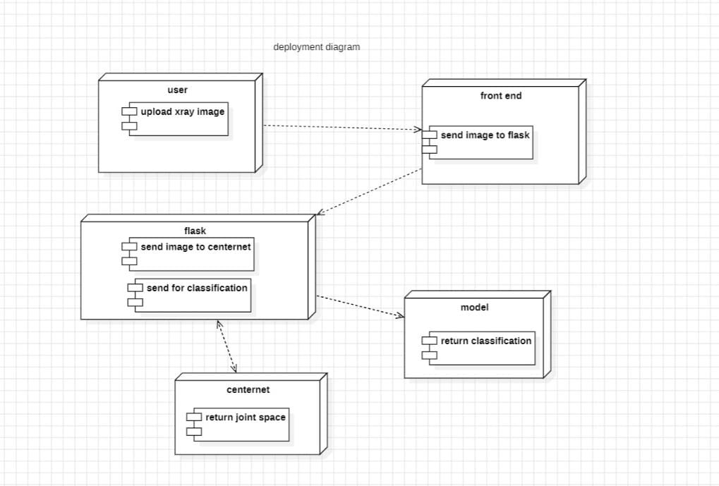

Fig 5.9 DEPLOYMENT DIAGRAM

